Test Plan for the Augment Evaluation Web Page Module
By Matthew Klump
March 13, 2004
- Introduction
The Augment Evaluation and Save Evaluation web pages are meant to provide the structure for which will be contained the feature of OwlEval that will allow Administrators and Faculty the ability to add additional questions to the standard set of questions that the students will answer for each course evaluation.
To our great pleasure, this feature was requested specifically by the OIT faculty and administration. It is an honor to include it for this version of the online course evaluation system that will replace the currently over burdensome paper based system.
- Relationship to other documents
We have broken the OwlEval system into five components:

- Student evaluation completion
- Faculty login and reports viewing
- Evaluation augmentation
- Evaluation creation and key generation
- Database access
This is the third module of five in all that will fully implement the OwlEval online course evaluation.

- System overview
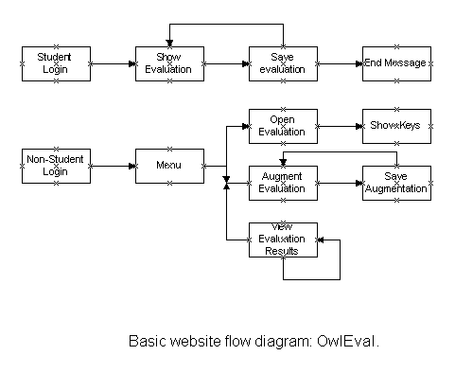
In the grand scheme of the OwlEval web design, Augment Evaluation is the second webpage that can be navigated to from the Administrator/Faculty menu page. The complete Augment Evaluation Module comprises of the webpage to enter and to review the additional questions to add with the standard questions for saving to the database (Save Augmentation).
- Features to be tested/not to be tested
Feature | Location | Desired outcome
Non-Student Login | n/a | Not tested here
Menu | n/a | Not tested here
Open Evaluation | n/a | Not tested here, but checking will be conducted for an open/current evaluation.
Select how many questions to add | Augment Evaluation | The current standard questions and the number of selected additional question text boxes are displayed for editing.  Changing questions a second time will first displays questions already entered.
Fill out extra questions | Augment Evaluation | The selected numbers of questions to add are entered.
Save evaluation | Save Evaluation | Erroneous input is detected and reported back to the Administrator/Faculty. If no erroneous input, then the evaluation is saved

- Pass/Fail criteria
Feature | Pass Criteria | Fail Criteria
Evaluation is already selected and open | Correct evaluation is displayed | Any browser error.  This indicates that an evaluation has not been opened based on the CRN number.
Select how many questions to add | The current standard questions and the number of selected additional question text boxes are displayed for editing. | Any browser error.  Anything other than the current set of questions for the current evaluation is displayed.
Select again how many questions to add | The questions already added are displayed again with the current standard questions. | Any browser error.  Anything other than the current standard question with the added question are displayed.
Fill out extra questions | Something is entered, excluding blanks, up to the number of questions selected to add. | Non-entry browser error.  This indicates that nothing is entered including one or more blank spaces with nothing else for one or more of the question text boxes displayed for entry.
Save Evaluation | All items are transmitted to the database for storage. | Any browser error.  This indicates that not all items were successfully transmitted to the database for storage, and in their proper places.

- Approach
(Comment credit to Glenn Diviney)
To test these features, the basic page framework will be constructed with external variables assumed and proper. Each feature will be constructed and verified with all feasible inputs in an attempt to crash the system.
- Suspension and resumption
Since each page must complete processing before it is displayed to the user (because it will be written in PHP), any error condition must be noted and displayed as part of the normal page processing routine. Suspension and resumption will generally be handled in this way.
- Testing materials (hardware/software requirements)
One PC with PHP and MySQL installed locally.
- Test cases
Test Number | Test Description | Pass/Fail status
03-10-04_#1 | The Augmentation Page will display on OIT’s browser.
03-10-04_#2 | <Session ID> for the current user is valid at the time the Augmentation Page is displayed.
03-10-04_#3 | The <CRN> reference for the current open <evaluation> is valid (database reference to <evaluation> is non-null).
03-11-04_#4 | If <list of changes> already exists in the database for the current <CRN> reference to <evaluation>, then the current <list of changes> must be non-null.
03-11-04_#5 | If <list of changes> already exists in the database for the current <CRN> reference to <evaluation>, then the current <list of changes> must have at least one question entry.
03-11-04_#6 | The current <list of changes> does not exceed five questions/strings.
03-12-04_#7 | The current <list of changes> in the database does not exceed 120 characters per question.
03-12-04_#8 | When the save button is pressed the, the Save Evaluation page is displayed containing a success message with the CRN reference number.

- Testing schedule
When the testing phase is entered, the features will be tested over the period of one and a half week in the order of the test cases table.

